76. The barber claimed that he would be “richer than Mani” (line 32). How did he plan  
to do so? [2m]

e——————eerer— EE LLL LEN LLL LBL ey Ail TE ll Tl

77. Based on the passage, state whether each statement in the table below is  
true or false, then give one reason why you think so. [3m] -

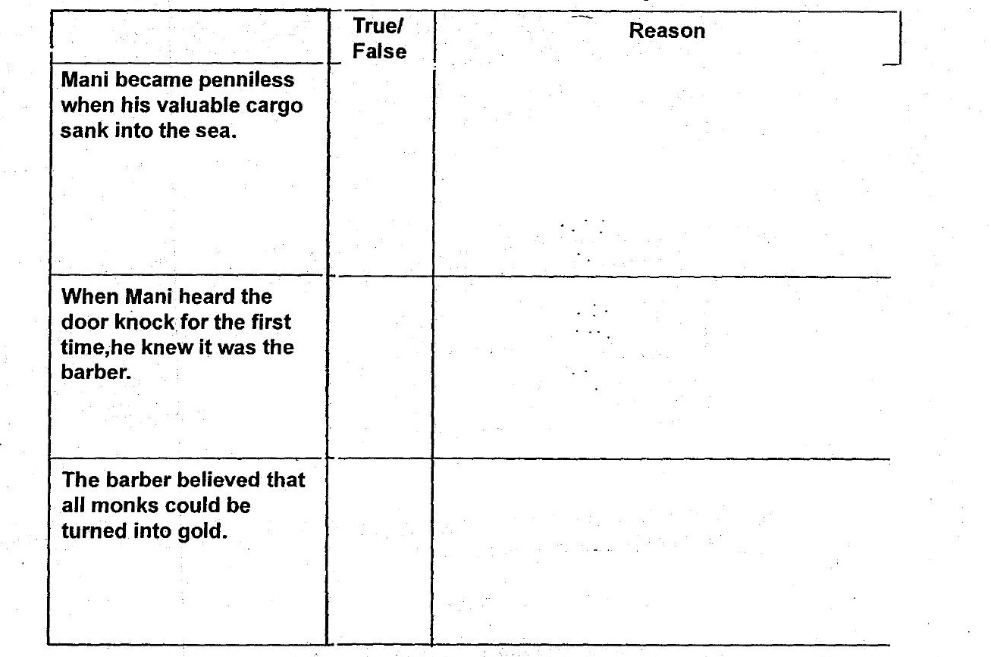

78. Why were the monks terrified of the barber? [2m] _